Python Programming Lab Task Sets
NAME:MOHAMMAD REHANA TABASSUM
ROLLNO:2503B05103

Set 3
- Q1. Implement a Python class for a stack data structure (`push`, `pop`, `peek`). Use GitHub Copilot to generate code, test its handling of edge cases, and explain any improvements made.
Prompt: Write a Python program that implements a Stack data structure using a python class .The class should support the (push,pop,peek )operations and include its edge cases handling and explain the improments made 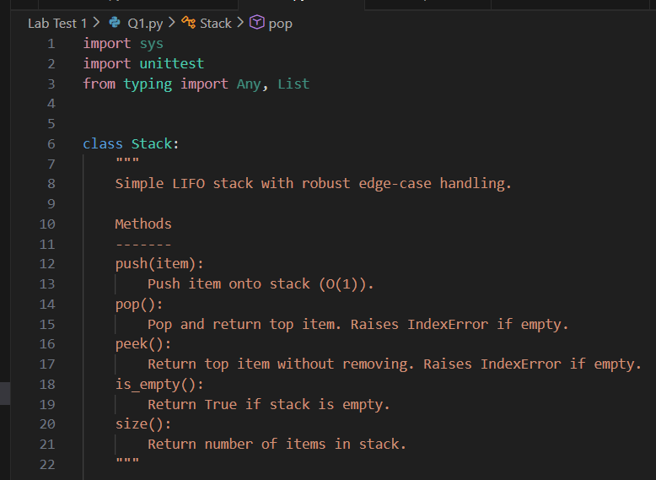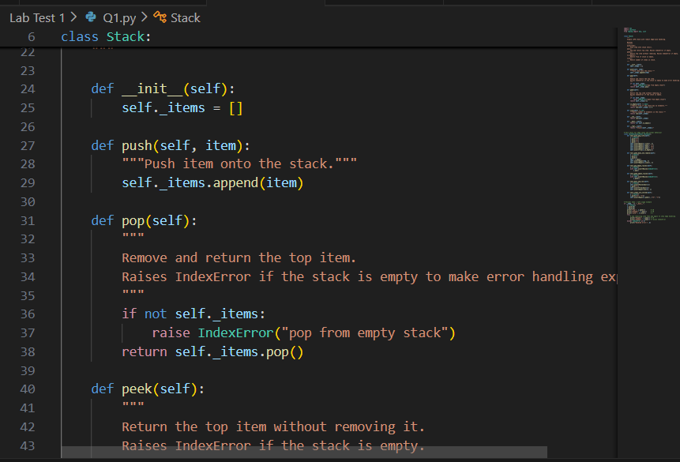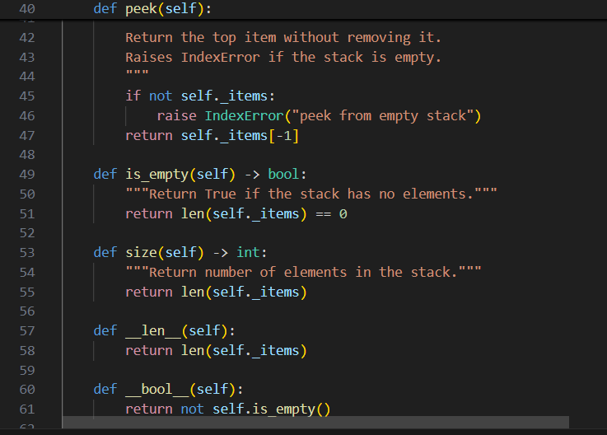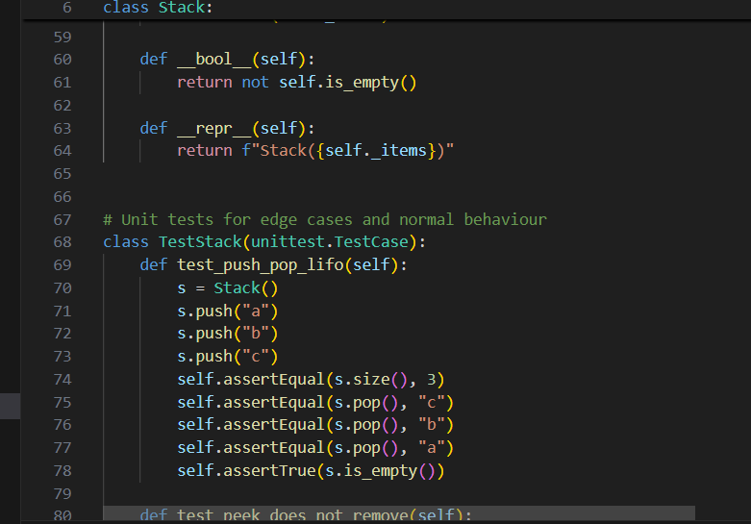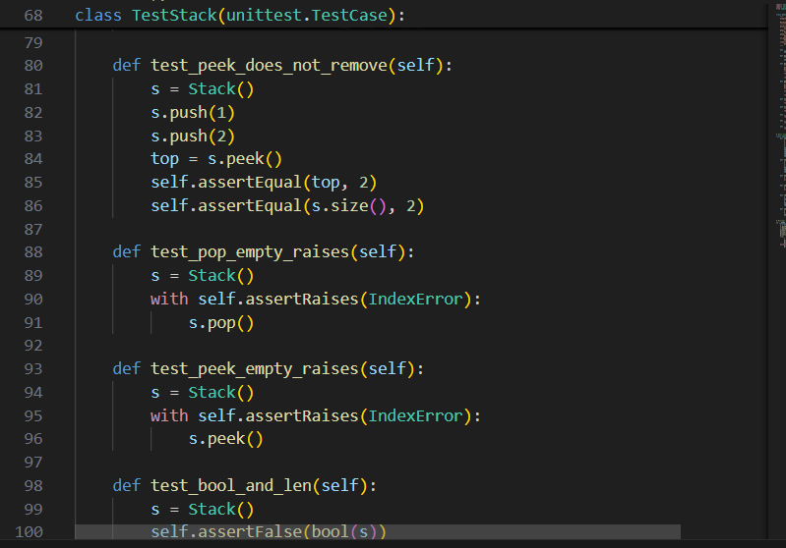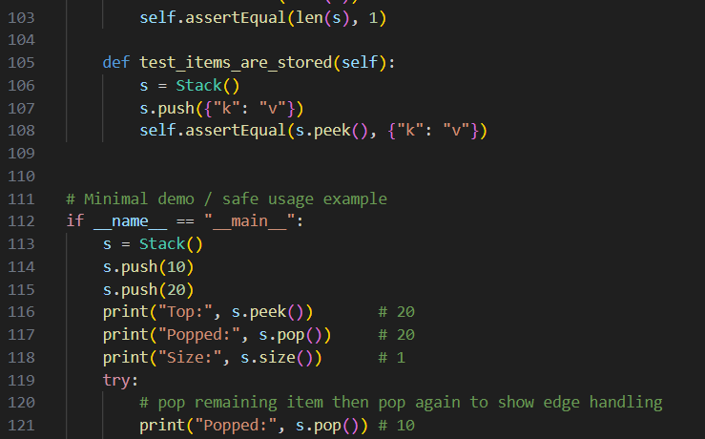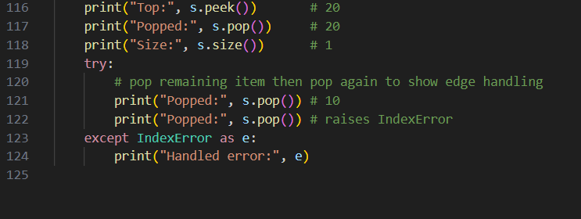 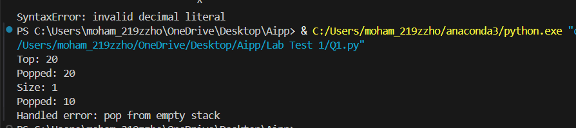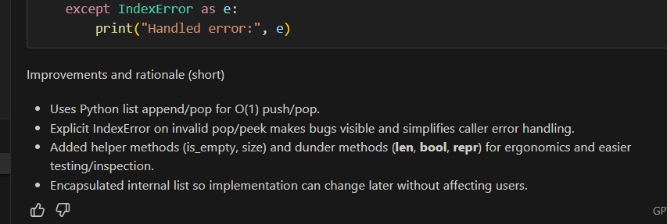
(Each question carries 5 marks)
- Q2. Refactor a poorly commented Python function using an AI assistant for automatic documentation. Evaluate clarity and completeness versus manual comments.
(Each question carries 5 marks)
Prompt: Refactor this poorly commented Python function by adding clear and complete documentation and comments. Then evaluate how the AI-generated documentation compares to manually written comments in terms of clarity and completeness.
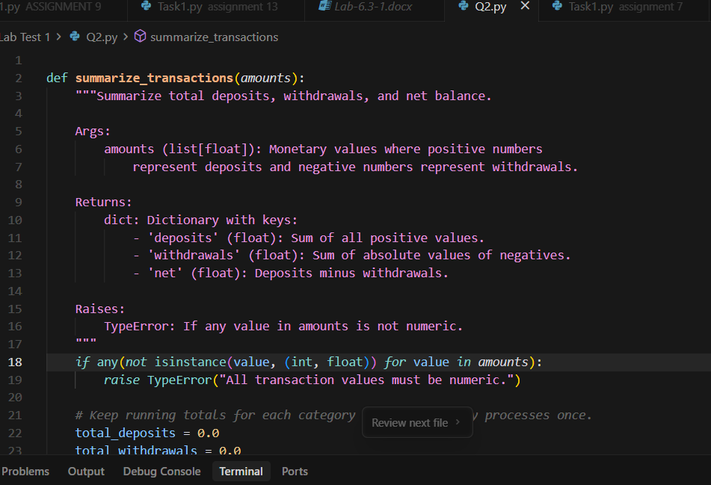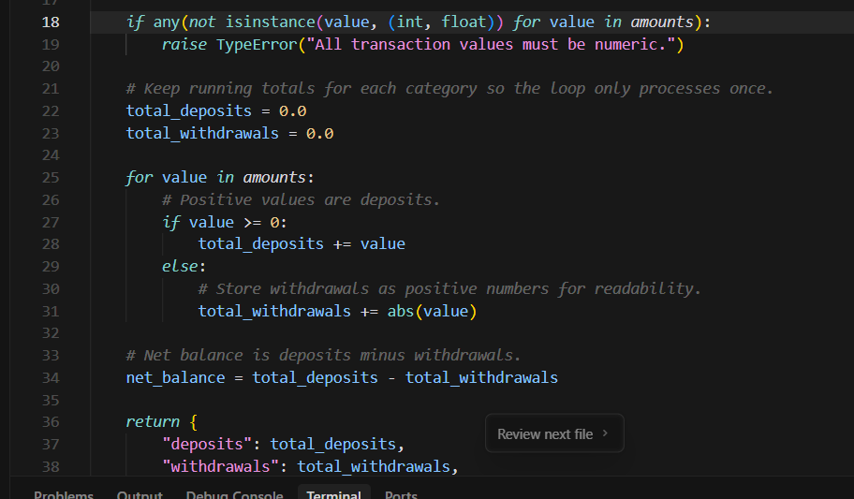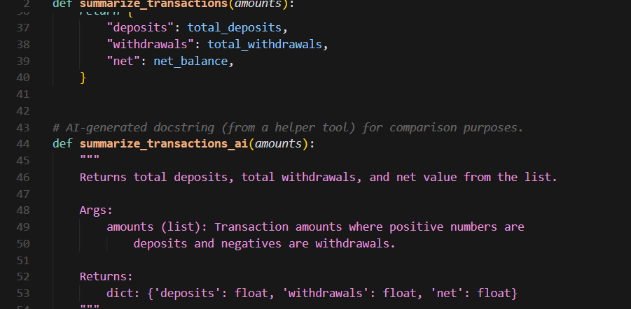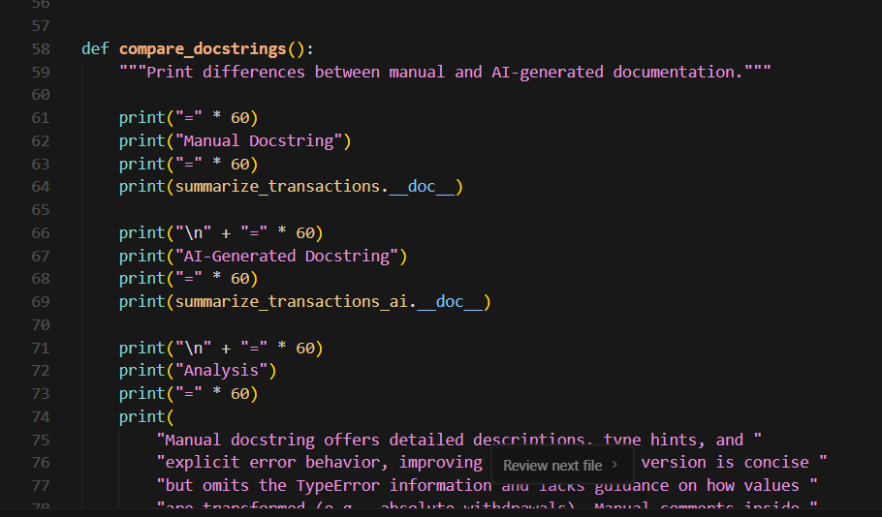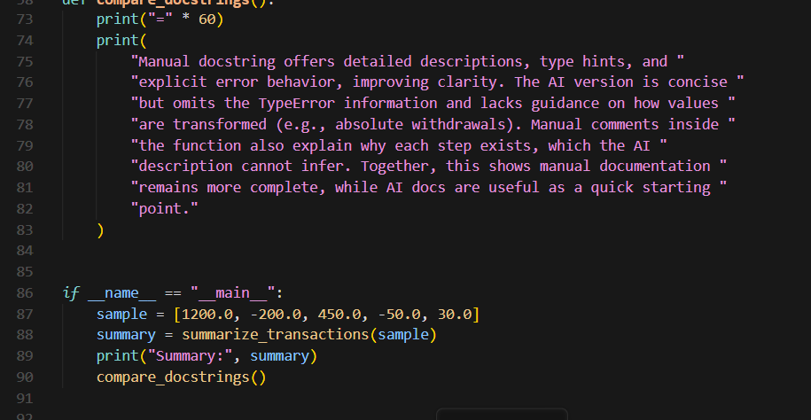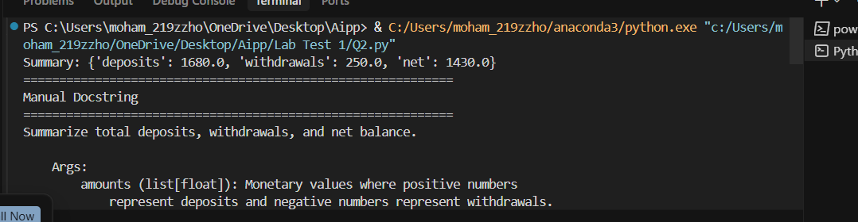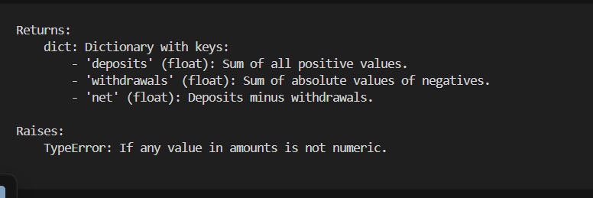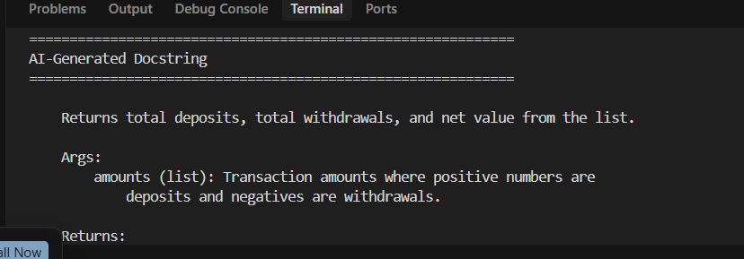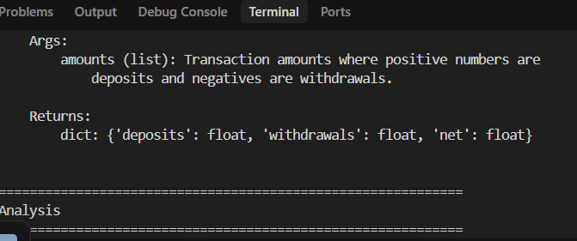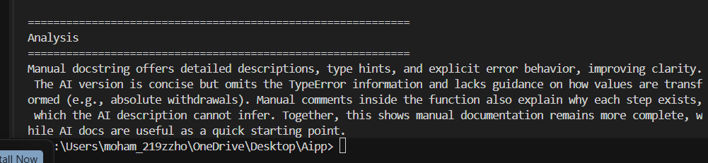Key changes
- Added a comprehensive Google-style docstring, inline comments explaining each step, and explicit type validation to summarize_transactions().
- Included summarize_transactions_ai() to illustrate an AI-generated docstring and highlight missing details (error handling, transformation logic).
- Added compare_docstrings() plus a small demo in __main__ to print both docstrings and evaluate clarity/completeness.

